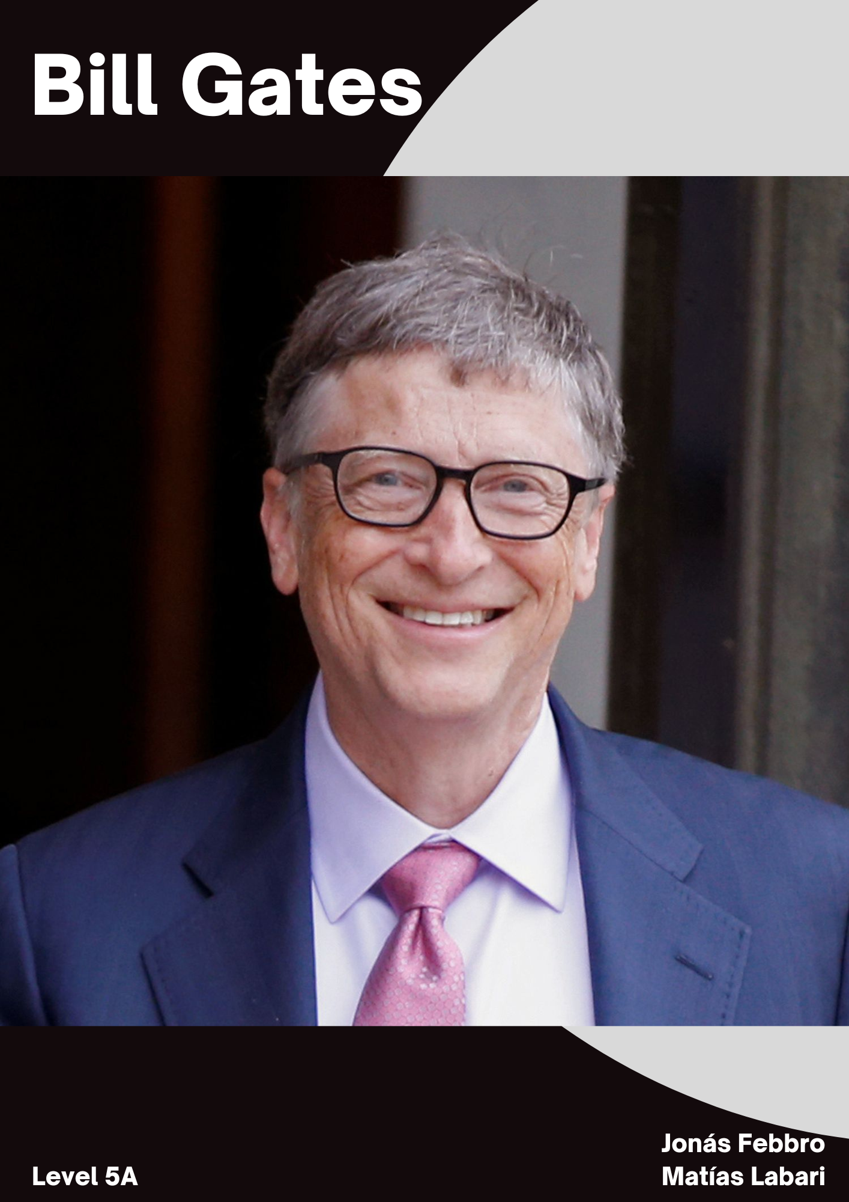

J and M: hello everyone, hope you are all good. We have today a marvelous guest. BILLLLLL GATES! Let’s get started. How are you Mr. Gates?

Bill: thanks for inviting me. I am glad to be here.

J an M: can you tell us about your life?

Bill: I was born on October 28, 1955, in Seattle, Washington. I grew up in an upper-middle-class family with my older sister, Kristianne, and younger sister, Libby. My father, William H. Gates Sr., was a promising, if somewhat shy, law student when he met his future wife, Mary Maxwell. She was an athletic, outgoing student at the University of Washington, actively involved in student affairs and leadership.

J and M: perfect, let’s talk about your childhood now. How was your childhood?

Bill: My family atmosphere was warm and close, and we were encouraged to be competitive and strive for excellence. I showed early signs of competitiveness when I coordinated family athletic games at their summer house on Puget Sound. I also relished playing board games (Risk was my favorite) and excelled at Monopoly.

J and M: and what about the relationship with your parents?

Bill: I had a very close relationship with his mother, Mary, who after a brief career as a teacher devoted her time to helping raise the children and working on civic affairs and with charities. She also served on several corporate boards, including those of the First Interstate Bank in Seattle (founded by her grandfather), the United Way and International Business Machines (IBM). She would often take us along when she volunteered in schools and at community organizations.

J and M: oh nice, what has made you help people?

Bill: It turns out that after one of my visits to places to promote computer technology, I arrived in Africa, and realized that the least they needed in that place was a computer. They lacked everything. They lived in total misery. That day my life had new goals and I began to believe that people's health is more important than keeping them connected with, for example, the internet.

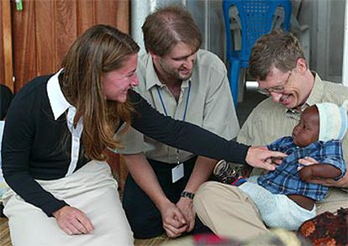

J and M: That is why we can see how Bill gates donates a lot of money. He plans to eradicate Malaria and it is clear that a healthy world is more important than anything else. Moreover, what about the consequences?

Bill: The consequences were good for the people that I helped, they lived in very poor conditions and thanks to the donations, many diseases were avoided, for example, Malaria. Economically, I had negative consequences, I stopped being the richest man in the world due to all the money I donated.

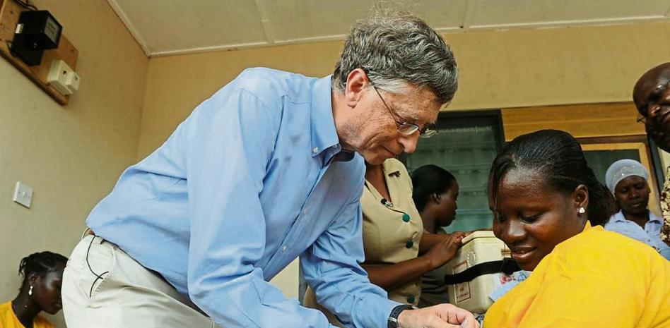

J and M: great and further to this, can you tell us an anecdote?

Bill: The first time I spoke to Nelson Mandela was in 1994, when he asked me to help finance South Africa's first multiracial elections. It's not every day that Nelson Mandela calls you. That is why I remember it so well. Back then, I was running Microsoft and software was on my mind pretty much all day. Nevertheless, I admired Nelson Mandela, and I knew that those elections would be historic, so I did everything in my power to help.

Just the year before, I had visited Africa for the first time, on vacation with my wife Melinda in East Africa. Of course, we knew that there were regions of Africa that were very poor, but that trip to the African continent opened our eyes to an injustice, so overwhelming, that it was impossible for us to ignore it.

Overwhelmed by that crude inequality, we began to consider what to do to improve things. Within a few years, we created our foundation. I was able to meet Nelson Mandela personally when I started coming to Africa regularly for foundation issues. He was both an advisor and a source of inspiration.

J and M: We as journalists believe that the donations, the foundations and all this type of help that we offer shows what a great person he is and the giant heart he has. Thanks to people like him, we value what we each have and we realize that money is not the most important thing, but health. He said that when he dies he will donate all his money to charity, and we think it is a beautiful act since he helps, as we said, many people in poor living conditions.